Assignment 3

Focus Alarm

Info1113 s11

By: Bruce Phan 100314408

Riley Mullen 100381800

Eddie Ye 100341563

Dr. Abhijit Sen

November 7, 2019

<https://sites.google.com/view/brucephanassignment1/my-personal-profile>

<https://github.com/brucekpu/Assignment3>

<https://github.com/zyeesi/Info1113Assignment3>

<https://github.com/rileymullen7/Assignment3>

Table of content

Contents

Introduction 3

List of functions 3

Screen shots of all functions available 4

Use cases 4

Use case descriptions 5

Conclusions 7

Figure 1 Use case diagram 4

# Introduction

The goal of this assignment is to create a use case diagram and descriptions for our group project, in our case it is going to be about focus alarm (project name). Our project is a program on the computer that acts like an alarm system that will assist the user on focusing on their current tasks as switching to other programs will cause the alarm to go off after a certain delay until you either go back to the program or turn off the alarm.

The program will have a setting tabs where you are able to customize a bunch of settings. For the alarm setting you will be able to change the volume and ringtone of the alarm when it goes off. For the Procrastinate part in setting you will be able to change the time interval of when the alarm goes off. In the color setup you will be able to select which tabs and program will not cause the alarm to go off (when selecting other program, the alarm will go off). And finally the response control unit which will allow you to turn off the alarm or snooze the alarm with a set time delay.

# List of functions

Alarm setting- volume and ringtone settings

Procrastinate Setting – setting for the time interval when the alarm will go off

Color setup- aka the focus program where you select the program or tab(s) where if you change from those set tabs the alarm will go off

Response control- how you would like to turn off the alarm or snooze the alarm

# Screen shots of all functions available

# Use cases

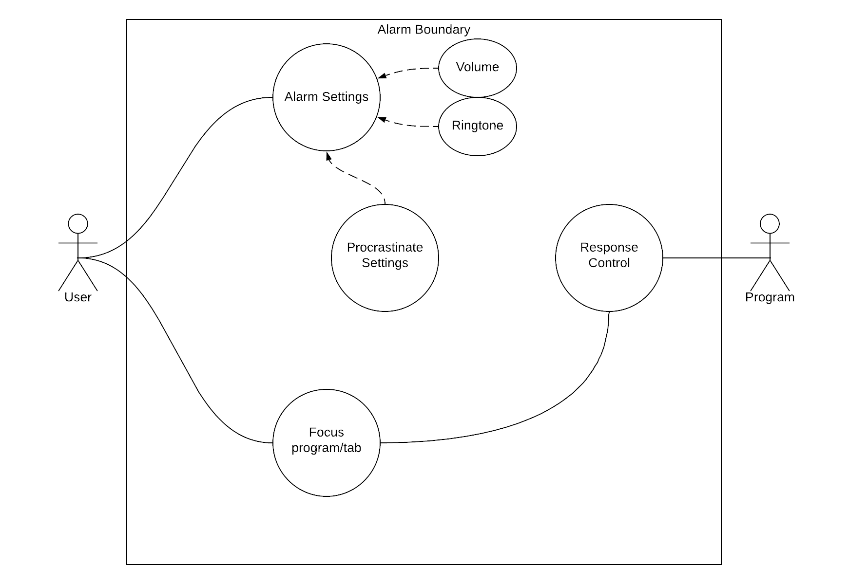

Figure 1 Use case diagram

# Use case descriptions

**Use case descriptions for focus program/tab**

Use case Title: focus program/tab

Primary Actor: User

Level: User Goal

Stakeholder: User

Precondition: User clicks on run program

Minimum Guarantee: Save user setting

Success Guarantee: Alarm setting all setup and working

Trigger Guarantee: Alarm working and ready to be Triggered

Main Success Scenario:

1. User setups the program (goes into setting and then saves his changed settings)
2. User uses focus program/tab and sets it up
3. Sets up time interval
4. Runs the program
5. Once the user changes program/tab the alarm will go off
6. The user turns off the alarm

Extension:

1. Response control once alarm activates
2. The user will decide to turn off the alarm or use the snooze function

Use case description for Procrastinate Settings

Primary Actor: User

Level: Black

Stakeholder: User

Minimum Guarantee: Saves user settings, default pick current program/tab

Success Guarantee: All set up and working

Trigger Guarantee: Settings correct and ready to be triggered

Main Success Scenario:

1. User goes into Procrastinate Settings
2. Set up how the time you have been procrastinate in before the program acts
3. Set up maybe exceptions
4. Save and exit Procrastinate Settings

Extensions: None

**Use case descriptions for focus program/tab**

Title: Alarm settings

Primary Actor: User

Level: User

Stakeholder: User

Precondition: User ready

Minimum Guarantee: Default Settings are used.

Success Guarantee: All alarm settings are set up individually to the user and working.

Trigger Guarantee: Alarm is setup properly and the program is ready to be used.

Main Success Scenario:

1. User starts program
2. User inputs all desired settings for alarm
3. User uses program and when changes tabs, alarm sounds to it’s liking.

Extension:

1. setup system all works and settings work
2. User friendly setup.

# Conclusions

In conclusion we learned how to create a use case diagram and use case descriptions with system requirements for our group project. We learn how to break apart our program into smaller more digestible parts and create use cases for the smaller parts. As we get more proficient on creating use cases and use case diagram we will ultimately get more better as system analysis.